1 For immediate release: 25.06.2017

PRESS RELEASE
WALK ‘D’ WALK FASHION SHOW 2017: UNIFYING CULTURES:
By
M & G Productions: Paving the way…

M & G Productions, is carrying out their first event for 2017, Walk ‘D’ Walk Fashion Show 2017: Unifying Cultures. We will be collaborating with the following fashion professionals - Fashion Designers, Makeup Artists, Hair Stylists, Artists and Fashion Accessories Manufacturers. All from diverse cultures and backgrounds:
As a charity, our members who are skilled in the fashion/Arts profession, will design, in collaboration with and supported by some of the fashion professionals listed above. The final products will be displayed at the Walk ‘D’ Walk fashion show 2017.
This event will take place on Saturday the 29th of July 2017 from 16:30pm to 21:00pm, at the Guildhall of Church of Christ the Cornerstone, 300 Saxon Gate, Milton Keynes MK9 2ES.
The Honourable Mayor of MK – Councillor David Hopkin will be in attendance.
M & G Productions was established in January 2015. We organize events that explore and promote inclusion, networking, and motivation of the marginalized and unemployed over 18’s with creative talents in the Milton Keynes community.
Our objective is to showcase group projects or productions of our participants, to Creative Media Organisations and the MK community at large.
This will enable participants to pursue or create employable opportunities in their individual skills.
This work has been supported by funding from the MK Community Foundation.

Contact details:
Anthonia N Beddall
Chair
Tel: 07791130085
Twitter: @MGProductions8
Instagram: info.mandgproductions
W/Site: www.mightandgraceproductions.com
Email: info.mandgproductions@yahoo.co.uk
Facebook: fb.me/paveway67
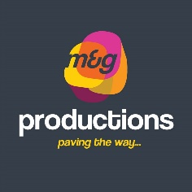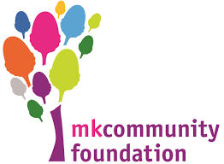
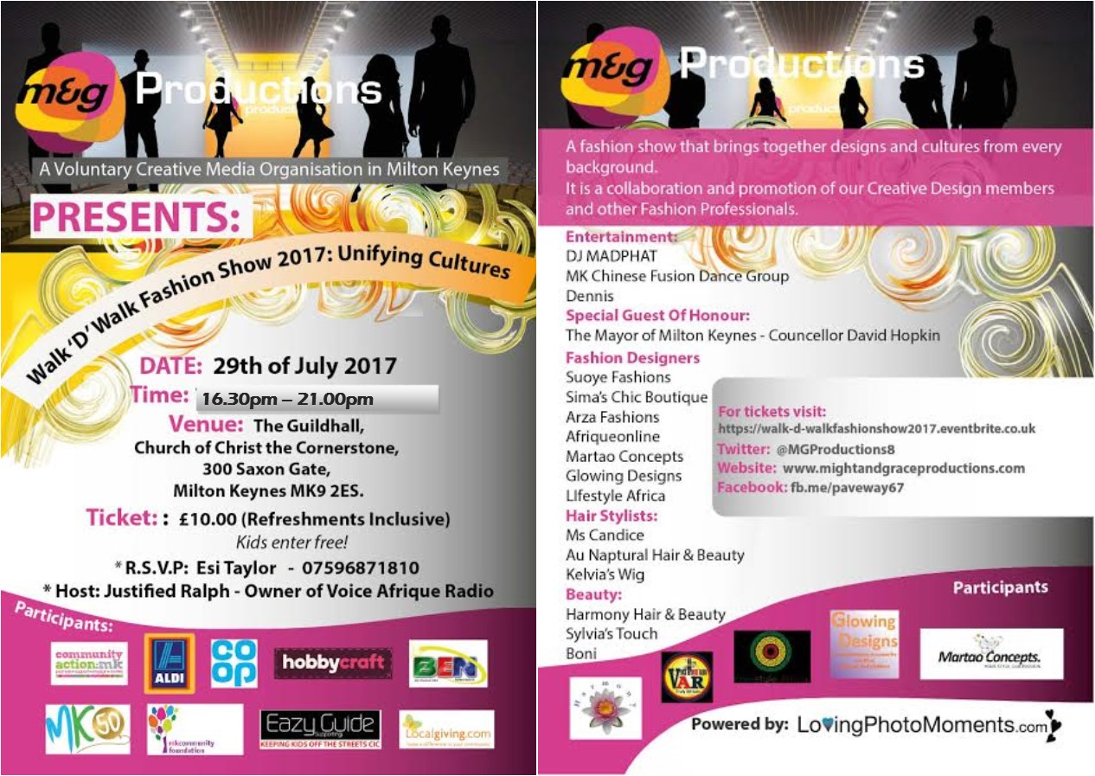

Dear Mr Ashley Tabor,

Attached is our Press release and Leaflet detailing our upcoming, Walk ‘D’ Walk Fashion Show 2017: Unifying Cultures

Kind regards

